**Git & IntelliJ Assignment**

**1. What is the use of the git add command?**

**Ans:** git add stages your changes, telling Git which files you want to include in your next commit. It prepares files for committing but doesn’t save them yet.

**2. Write the command to create a branch “feature-group”.**

**Ans:** git branch feature-group

**3. What is a pull request? Write the steps involved in creating a pull request.**

**Ans:** A pull request lets us tell others about changes I pushed to a branch in a repository. It’s used to request merging those changes into another branch, usually main.

1. Push your feature branch to GitHub.
2. Go to the repository on GitHub.
3. Click on **"Compare & pull request"**.
4. Add a title and description, then click **"Create pull request"**.

**4. How do you add collaborators?**

**Ans:** Go to your repository on GitHub, click **Settings > Collaborators**.  
Enter the username or email of the person and click **Add collaborator**.

**5. What is the command used to commit our changes in GitHub repo?**

**Ans:** git commit -m " Message"

**6. Create a GitHub account and repository to save all your assignment tasks. Example repository name: rg-assignments.**

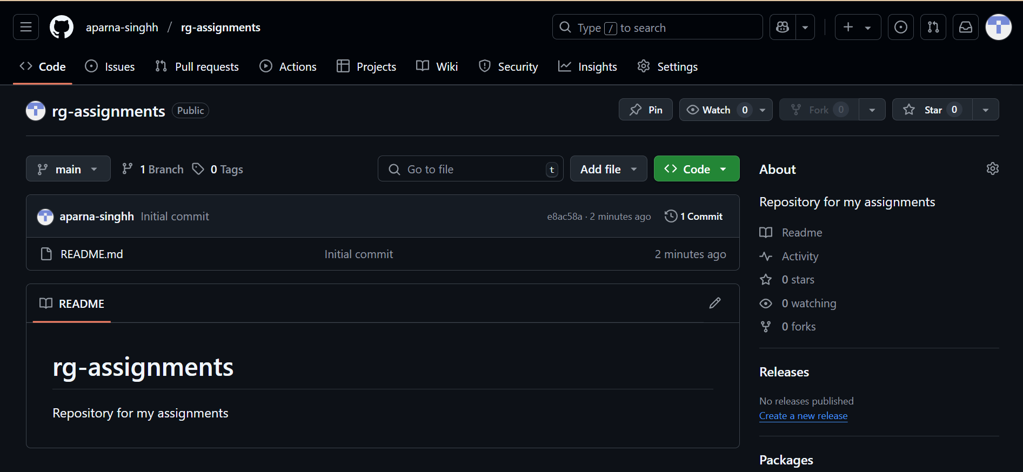

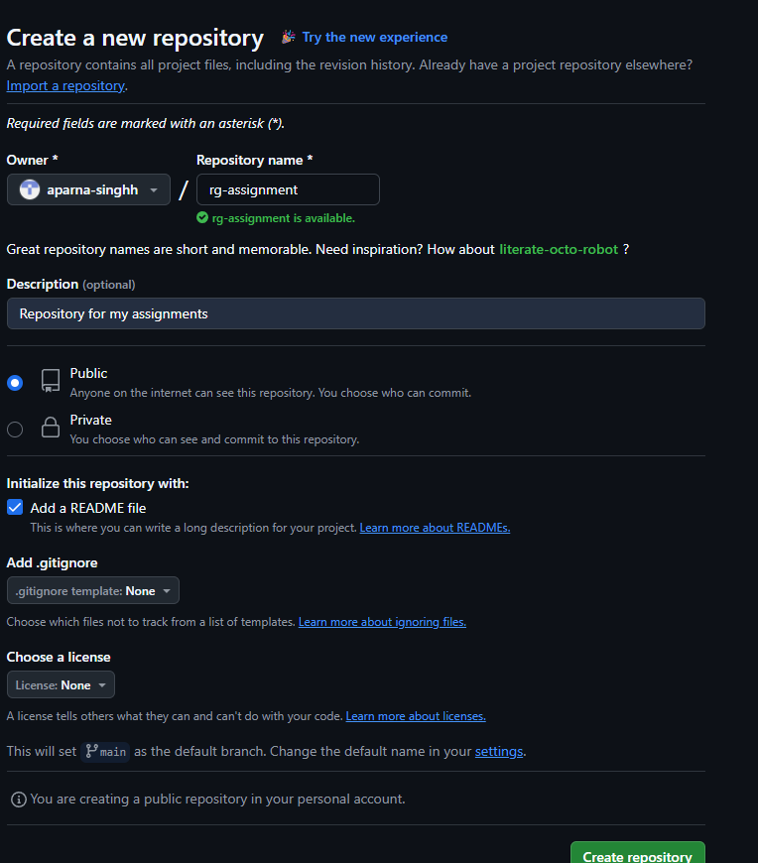

**7. Create a branch called feature-java.** **(you can use it later to push all your java related tasks to this branch)**

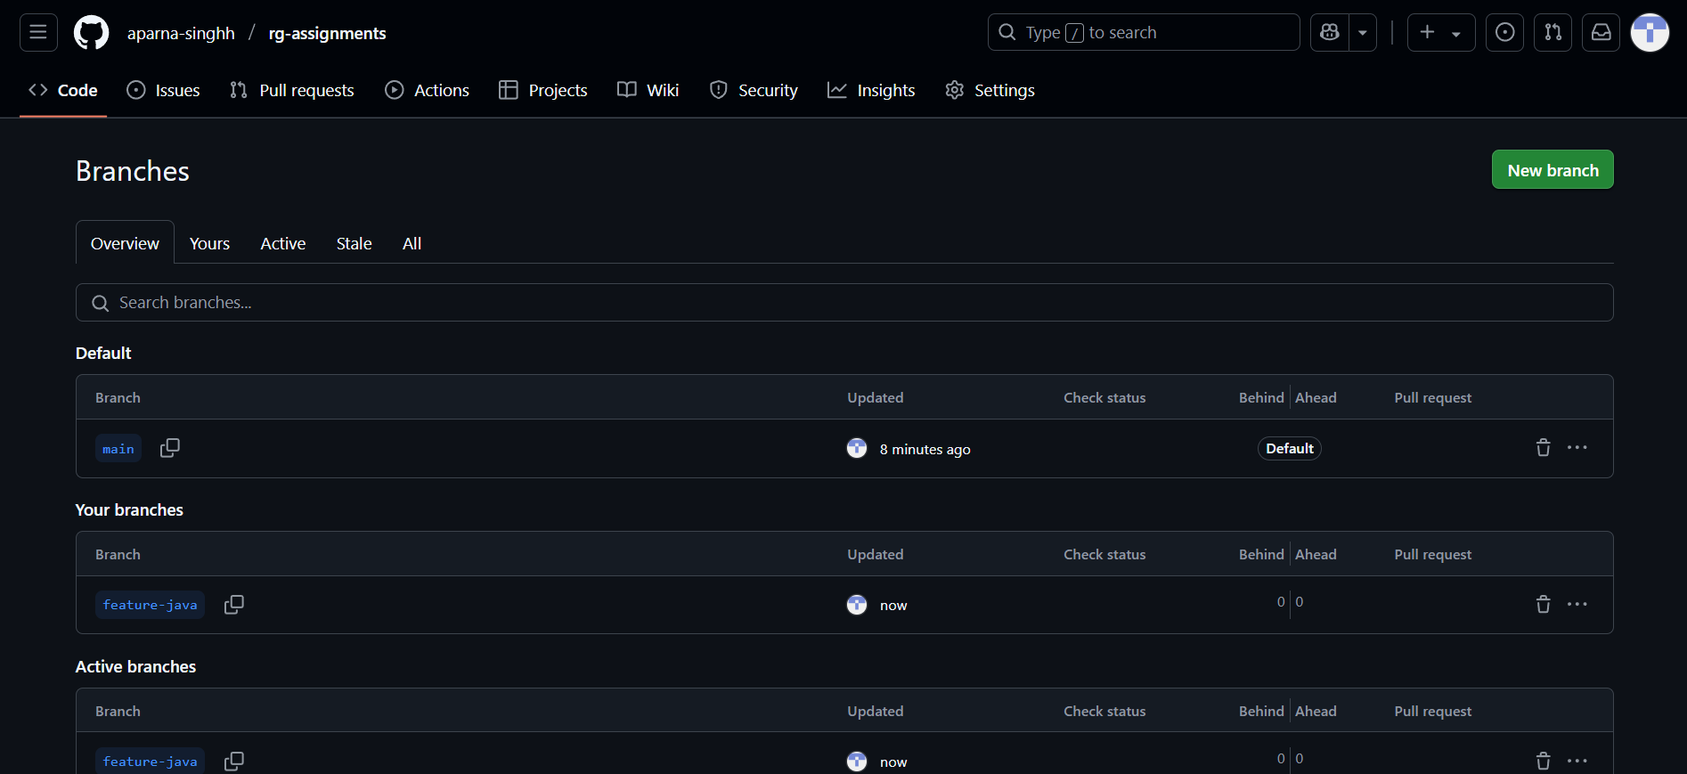

**8. Install IntelliJ IDE. Create a simple Java project displaying “Hello World!!” and share the screenshot.**

**Ans:**

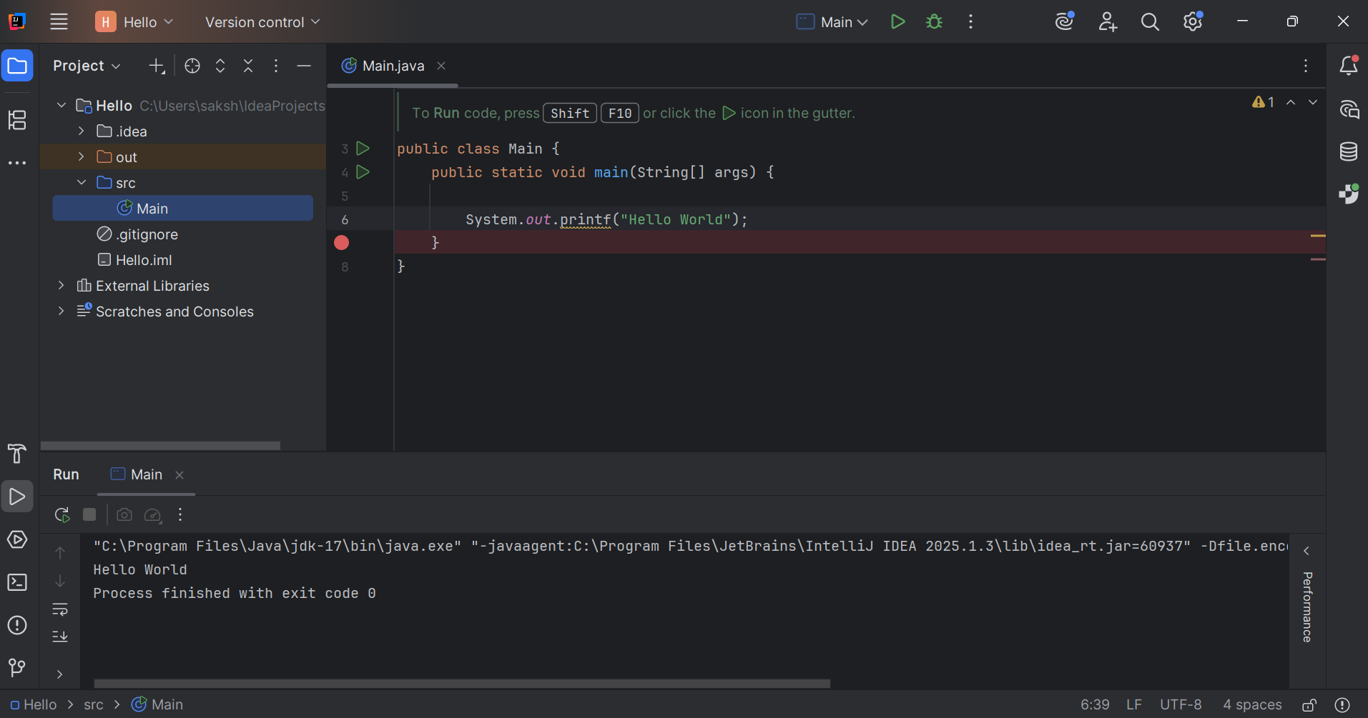

**9. In IntelliJ IDE, explore the shortcut keys for the following**

1. **To run the project**
2. **To select a line**
3. **To comment/uncomment a line**
4. **To delete a line**

**Ans:**

| **Action** | **Windows/Linux** | **Mac** |
| --- | --- | --- |
| Run the project | Shift + F10 | Control + R |
| Select a line | Home + Shift + End | Shift + Right/Left |
| Comment/Uncomment line | Ctrl + / | Command + / |
| Delete a line | Ctrl + Y | Command + Delete |